
MATHEMATICS DEPARTMENT
Year 11 Specialist – 2016
Test Number 2: Mathematical Proof
Resource Free

Name: _______________________________________ Teacher: DDA
Marks: 39
Time Allowed: 40 minutes
Weight: 3.5%
Instructions: You ARE NOT permitted any notes or calculator. Show your working where appropriate remembering you must show working for questions worth more than 2 marks.
_________________________________________________________________________
1 Consider the statements:
I If you have a driver’s licence then you are over 16.
II If you are not over 16 then you do not have a driver’s licence.
Which of the following is true?
A II is the converse of I.
B II is the contrapositive of I.
C II is a counterexample of I.
D II is the negative of I.
E II is the reverse of I.

[1 mark]
2 Consider the argument:
All fish live in water.
A turtle lives in water.
Therefore a turtle is a fish.
The argument is:
A a contrapositive
B inductive
C a contradiction
D invalid
E a counterexample.

[1 mark]
3 If is true then which statement is true?
A P Q
B P Q
C Q P
D Q P
E

[1 mark]
4 The values x = 3, y = −2 would be a counterexample to which of the following?
A x > y x2 > y2
B x > y
C x > y xy > y2
D x > y x2 > xy
E x > y

[1 mark]
5 You would use the SAS test to prove which pair of triangles congruent? (Circle the correct answer)
A 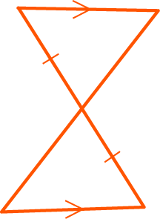
B 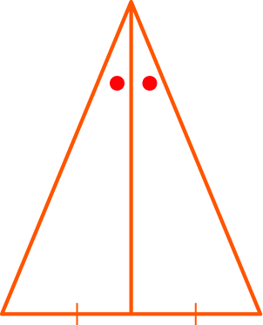
C 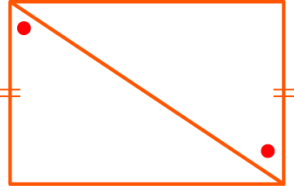
D 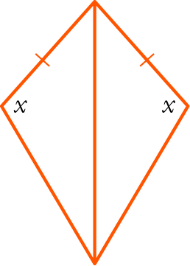
E None of the above.

[1 mark]

6 Write the statement below using mathematical notation.
For all rational numbers x there exist integers p and q where q is non-zero such that .

[3 marks]

7 For the statement:
If you drink too much alcohol then you will get alcohol poisoning.
a Write the converse.

b Write the inverse.

c Is the statement an equivalence? Give reasons.

[4 marks]

8 Consider the two premises:
P: A quadrilateral is a rhombus.
Q: A quadrilateral has diagonals that bisect each other at right angles.
a Write P Q.

b Write Q P.

c Is it true that P Q? If so, write a statement linking P and Q using iff.

True or False? __________

[3 marks]
9 Complete the proof that is irrational.
Proof: Assume that is rational, i.e. ∃ m, n ∈ Z, n ≠ 0 such that,
where m, n have no common factors.
Then squaring both sides: 2 =
∴ is irrational.

[6 marks]
10 For each statement below, consider the contrapositive statement to determine whether or not the statement is true. Justify your reasoning.
a If pensioners have electronic devices then they send emails.
Contrapositive:

b If a number is divisible by 4 then it is even.
Contrapositive:

[5 marks]

11 In the diagram, AB ⊥ AC, AD ⊥ BC, BD = 4, DC = 9, AD = x.
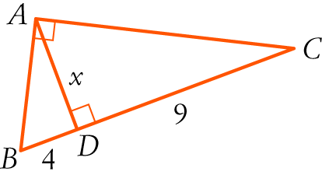

a Prove that Δ ABD ||| Δ CAD. Make you justify every line with a reason or rule.

In $∆ABD$ and $∆CAD$:
= ( )
= ( )
$∴$ ( )

b Hence find the value of x.

[6 marks]
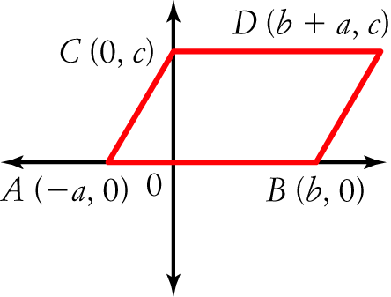
12 Consider the diagram with coordinates (−a, 0), (b, 0), (0, c), (b + a, c) representing the points A, B, C, D respectively, such that ABDC is a parallelogram.

a Determine the length of each of the following in terms of $a,b$ and $c$.

AB = | CD =
AC = | BD =
AD = | BC =

b Hence, write an expanded expression for each of the following in terms of $a,b$ and $c$.

i) AB2 + DB2 + DC2 + CA2

ii) AD2 + CB2

c What property of a parallelogram does this demonstrate?

[7 marks]

